COLLEGE NAME.CITY

COLLEGE LOGO

## DEPARTMENT

## OF

## ELECTRONICS & COMMUNICATION

**LAB MANUAL**

**“ COMMUNICATION system”**

***BACHELOR OF ENGINEERING (B.E.) COURSE***

***Name: ______________________________________***

***Semester: ___________________________________***

***Branch: _____________________________________***

***Enrollment No. _______________________________***

**DEPARTMENT OF ELECTRONICS**

**AND COMMUNICATION**

**LAB MONOGRAPH**

**COMMUNICATION SYSTEM**

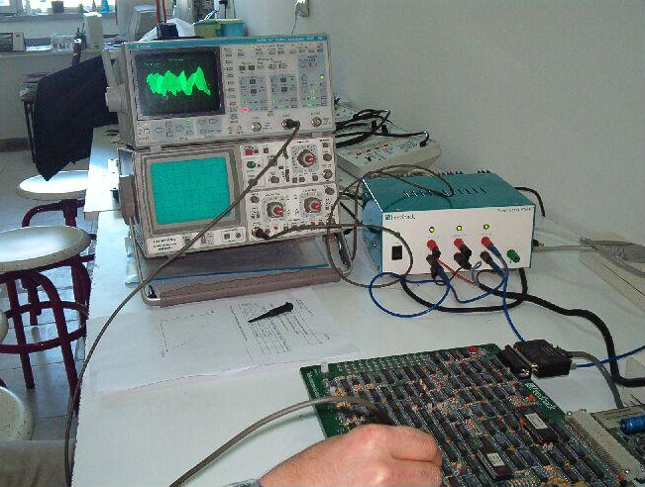**.**

**INDEX**

1. **General Introduction**
2. **Experiments as per RGPV Syllabus**

|  |  |  |  |
| --- | --- | --- | --- |
| **S.NO.** | **EXPERIMENT** | **DATE** | **SIGN** |
| 1 | Study of Sampling Process and Signal Reconstruction and Aliasing**.** |  |  |
| 2 | Study of PAM, PPM and PDM. |  |  |
| 3 | Study of PCM transmitter and receiver. |  |  |
| 4 | Time division multiplexing (TDM) and De multiplexing |  |  |
| 5 | Study of ASK, PSK and FSK transmitter and receiver. |  |  |
| 6 | Study of AM modulation and Demodulation techniques (Transmitter and Receiver) Calculate of parameters. |  |  |
| 7 | Study of FM modulation and demodulation (Transmitter and Receiver) & Calculation of parameters. |  |  |
| 8 | To construct and verify pre emphasis and de-emphasis and plot the wave forms. |  |  |
| 9 | Study of super heterodyne receiver and characteristics of ratio radio receiver |  |  |
| 10 | Study of AVC and AFC. |  |  |
| 11 | Study of phase modulation. |  |  |
| 12 | Study of phase demodulation. |  |  |
| 13 | Analysis of voltage controlled oscillator using PLL chip (565). |  |  |

**EXPERIMENT NO-1**

**AIM:-**

**Study of Sampling Process and Signal Reconstruction and Aliasing.**

**APPARATUS REQUIRED:-**

1. ST2101 with power supply cord.
2. Oscilloscope with connecting probe.
3. Connecting cords.

**THEORY:-**

The signals we use in the real world, such as our voice, are called "analog" signals. To process these signals for digital communication, we need to convert analog signals to "digital" form. While an analog signal is continuous in both time and amplitude, a digital signal is discrete in both time and amplitude. To convert continuous time signal to discrete time signal, a process is used called as sampling. The value of the signal is measured at certain intervals in time. Each measurement is referred to as a sample.

**Principle of sampling:-**

Consider an analogue signal x(t) that can be viewed as a continuous function of time, as shown in figure. We can represent this signal as a discrete time signal by using values of x(t) at intervals of nTs to form x(nTs) as shown in figure . We are “grabbing" points from the function x(t) at regular intervals of time, Ts, called the sampling period.

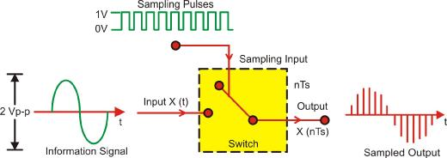

**Aliasing:**

A precondition of the sampling theorem is that the signal to be band limited. However, in practice, no time-limited signal can be band limited. Since signals of interest are almost always time-limited (e.g., at most spanning the lifetime of the sampling device in question), it follows that they are not band limited. However, by designing a sampler with an appropriate guard band, it is possible to obtain output that is as accurate as necessary. Aliasing is the presence of unwanted components in the reconstructed signal. These components were not present when the original signal was sampled. In addition, some of the frequencies in the original signal may be lost in the reconstructed signal. Aliasing occurs because signal frequencies can overlap if the sampling frequency is too low. As a result, the higher frequency components roll into the reconstructed signal and cause distortion of the signal Frequencies "fold" around half the sampling frequency. This type of signal distortion is called aliasing. We only sample the signal at intervals. We don't know what happened between the samples. A crude example is to consider a 'glitch' that happened to fall between adjacent samples. Since we don't measure it, we have no way of knowing the glitch was there at all.

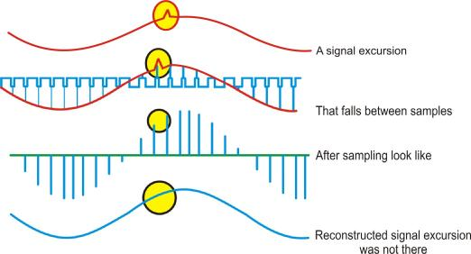

In a less obvious case, we might have signal components that are varying rapidly in between samples. Again, we could not track these rapid inter-sample variations. We must sample fast enough to see the most rapid changes in the signal. Sometimes we may have some a prior knowledge of the signal, or be able to make some assumptions about how the signal behaves in between samples.

**CIRCUIT DIAGRAM:-**

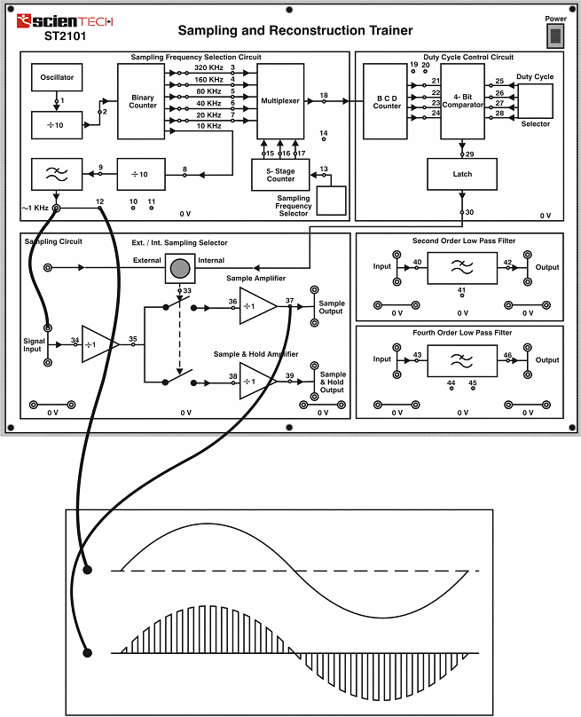

**Signal Sampling**

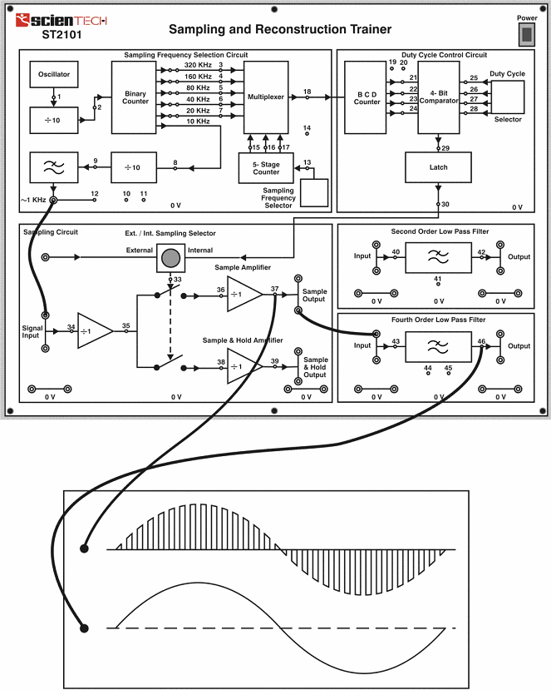**SIGNAL RECONSTRUCTION:-**

**Signal Reconstruction**

**PROCEDURE:-**

A. Set up for Sampling and reconstruction of signal. Initial set up of trainer: Duty cycle selectors switch position: Position 5.

Sampling selector switch: Internal position.

1. Connect the power cord to the trainer. Keep the power switch in ‘Off’ position.
2. Connect 1 KHz Sine wave to signal Input.
3. Switch ‘On’ the trainer's power supply & Oscilloscope.
4. Connect BNC connector to the CRO and to the trainer’s output port.
5. Select 320 KHz (Sampling frequency is 1/10th of the frequency indicated by the illuminated LED) sampling rate with the help of sampling frequency selector switch.
6. Observe 1 KHz sine wave (TP12) and Sample Output (TP37) on Oscilloscope. The display shows 1 KHz Sine wave being sampled at 32 KHz, so there are 32 samples for every cycle of the sine wave.
7. Connect the Sample output to Input of Fourth Order low pass Filter & observe reconstructed output on (TP46) with help of oscilloscope. The display shows the reconstructed original 1 KHz sine wave.
8. By successive presses of sampling Frequency Selector switch, change the sampling frequency to 2KHz, 4KHz, 8KHz, 16KHz and back to 32KHz (Sampling frequency is 1/10th of the frequency indicated by the illuminated LED). Observe how SAMPLE output changes in each cases and how the lower sampling frequencies introduce distortion into the filter’s output waveform. This is due to the fact that the filter does not attenuate the unwanted frequency component significantly. Use of higher order filter would improve the output waveform.
9. So far, we have used sampling frequencies greater than twice the maximum input frequency.

**CONCLUSION:-**

As the sampling frequency increases the output of sample port has more number of samples of applied input signal.

**B. Setup of Nyquist criteria and aliasing:-**

Initial set up of trainer: Duty cycle selector switch position: Position 5

Sampling selector switch: Internal position.

1. Keep the power switch in ‘Off’ position.
2. Connect 2 volts peak, 2 KHz sine wave from 600 ohms output of the Function Generator to the signal Input of the trainer.
3. Switch ‘On’ the trainer's power supply & Oscilloscope.
4. Connect BNC connector to the CRO and to the trainer’s output port.
5. Select 320 KHz (Sampling frequency is 1/10th of the frequency indicated by the Illuminated LED) sampling rate with the help of sampling frequency selector Switch.
6. Connect the sample output to fourth order low pass filter & observe the output (TP46) on oscilloscope. Observe the two waveforms (applied input signal & filter output) which are similar but the second waveform (filter output) is lagging in phase. This is as expected from filters phase/ frequency response.
7. Decrease the sampling rate from 32 KHz to 2 KHz. Observe the distorted waveform at filter's output (TP46). This is due to the fact that we under-sampled the input waveform overlooking the Nyquist criteria and thus the output was distorted even though the signal lies below the cut-off frequency (3.4 KHz) of the filter. This explains the phenomena of Aliasing.

**CONCLUSION:-**

As the input sampling frequency is smaller than the applied input signal then the output is distorted means the original signal cannot be reconstructed.

### EXPERIMENT NO–2

**AIM:-**

**Study of PAM, PPM and PDM.**

1. **Study of Pulse Amplitude Modulation using Natural & Flat top Sampling.**

**APPARATUS REQUIRED:-**

1. ST2110 with power supply cord.
2. CRO with connecting probe.
3. Connecting cords.

**THEORY:-**

Most digital modulation systems are based on pulse modulation. It involves variation of a pulse parameter in accordance with the instantaneous value of the information signal. This parameter can be amplitude, width, repetitive frequency etc. Depending upon the nature of parameter varied, various modulation systems are used. Pulse amplitude modulation, pulse width modulation, pulse code modulation are few modulation systems cropping up from the pulse modulation technique. In pulse amplitude modulation (PAM) the amplitude of the pulses are varied in accordance with the modulating signal. In true sense, pulse amplitude modulation is analog in nature but it forms the basis of most digital communication and modulation systems. The pulse modulation systems require analog information to be sampled at predetermined intervals of time. Sampling is a process of taking the instantaneous value of the analog information at a predetermined time interval. A sampled signal consists of a train of pulses, where each pulse corresponds to the amplitude of the signal at the corresponding sampling time. The signal sent to line is modulated in amplitude and hence the name Pulse Amplitude Modulation (PAM)**.**

**Natural sampling:-** In the analogue-to-digital conversion process an analogue waveform is sampled to form a series of pulses whose amplitude is the amplitude of the sampled waveform atb the time the sample was taken. In natural sampling the pulse amplitude takes the shape of the

analogue waveform for the period of the sampling pulse as shown in figure.

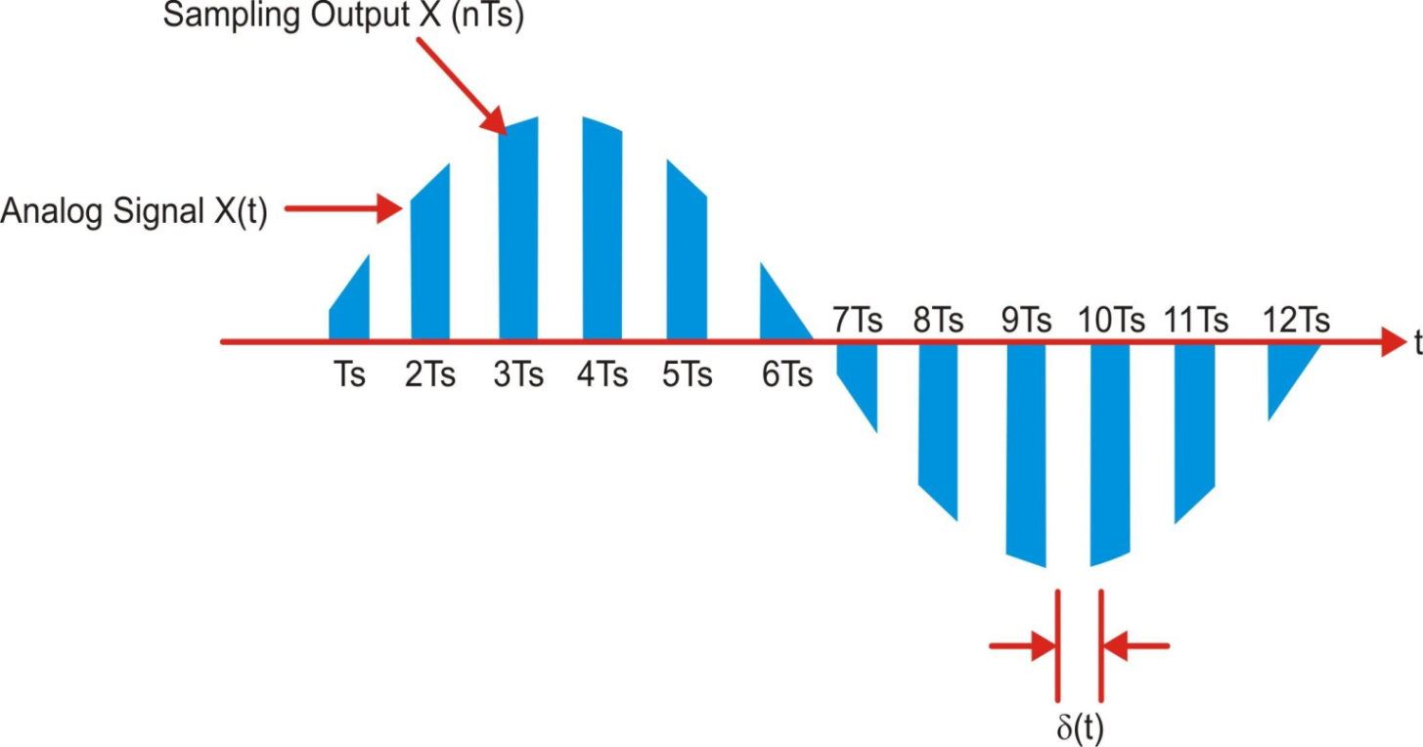

**Flat Top sampling:-**

After an analogue waveform is sampled in the analogue-to-digital conversion process, the continuous analogue waveform is converted into a series of pulses whose amplitude is equal to the amplitude of the analogue signal at the start of the sampling process. Since the sampled pulses have uniform amplitude, the process is called flat top sampling as shown in figure

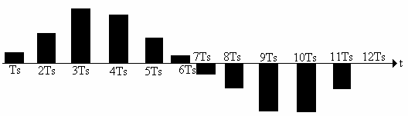

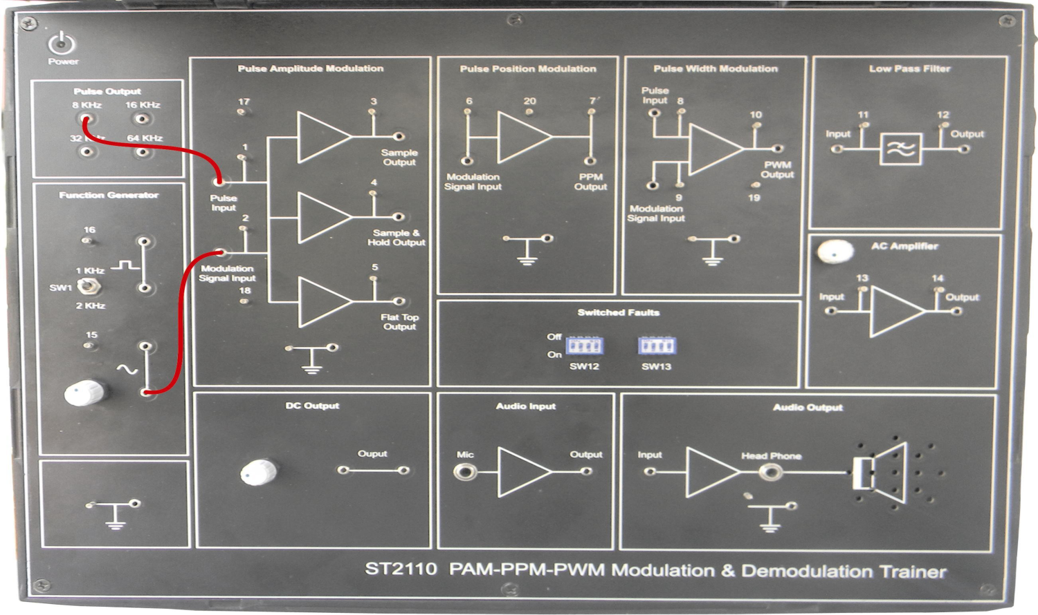**CIRCUIT DIAGRAM:-**

**PROCEDURE:-**

1. Connect the circuit as shown in Figure.

a. Output of sine wave to modulation signal input in PAM block keeping the switch in 1 KHz position.

b. 8 KHz pulse output to pulse input.

1. Switch ‘On’ the power supply & oscilloscope.
2. Observe the outputs at TP(3 & 5) these are natural & flat top outputs respectively.
3. Observe the difference between the two outputs.
4. Vary the amplitude potentiometer and frequency change over switch & observe the effect on the two outputs.
5. Vary the frequency of pulse, by connecting the pulse input to the 4 frequencies available i.e. 8, 16, 32, 64 kHz in Pulse output block.
6. Switch ‘On’ fault No. 1, 2, 3, 4 one by one & observe their effect on Pulse Amplitude Modulation output and try to locate them.
7. Switch ‘Off’ the power supply.

**RELATED O/P WAVEFORMS:-**

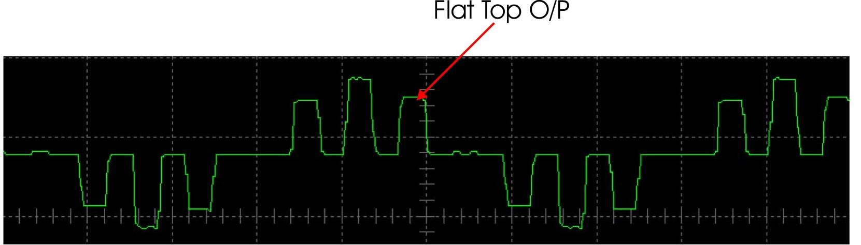

1. **Study of PPM using DC Input, Sine wave Input.**

**APPARATUS REQUIRED:-**

1. ST2110 with power supply cord.
2. CRO with connecting probe.
3. Connecting cords.

**THEORY:-**

The Amplitude and width of the pulses is kept constant in this system, while the position of each pulse, in relation to the position of a recurrent reference pulse is varied by each instantaneous sampled value of the modulating wave. As mentioned in connection with pulse width modulation, pulse-position modulations has the advantage of requiring constant transmitter power output, but the disadvantages of depending on transmitter receiver is synchronization.

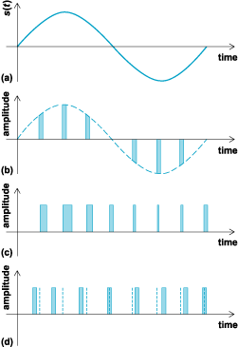

1. **Analog signal. (b) Pulse-amplitude modulation. (c) Pulse-width modulation. (d) Pulse-position modulation.**

there may be a sequence of signal sample amplitudes of (say) 0.9, 0.5, 0 and -0.4V. These can be represented by pulse widths of 1.9, 1.5, 1.0 and 0.6μs respectively. The width corresponding to zero amplitude was chosen in this system to be 1.0μs, and it has been assumed that signal amplitude at this point will vary between the limits of + 1 V (width = 2μs) and -1 V (width = 0μs). Zero amplitude is thus the average signal level, and the average pulse width of 1μs has been made to correspond to it. In this context, a negative pulse width is not possible. It would make the pulse end before it began, as it were, and thus throw out the timing in the receiver. If theb pulses in a practical system have a recurrence rate of 8000 pulses per second, the time between the commencements of adjoining pulses is 106 /8000 =125μs. This is adequate not only to accommodate the varying widths but also to permit time-division multiplexing. Pulse width modulation has the disadvantage, when compared with pulse position modulation, which will be treated next, that its pulses are of varying width and therefore, of varying power content. This means that the transmitter must be powerful enough to handle the maximum-width pulses, although the average power transmitted is perhaps only half of the peak power. On the other hand, puls width modulation still works if synchronization between transmitter and receiver fails, whereas pulse-position modulation does not, as will be seen.

**FOR DC INPUT:-**

**CIRCUIT DIAGRAM:-**

**PROCEDURE:-**

1. Connect the circuit as shown in Figure and also described below for clarity.

a. Connect the DC output to input of PPM block.

1. Switch ‘On’ the power supply & oscilloscope.
2. Observe the output of PPM block at TP7.
3. Vary the DC output while observing the output of PPM block.
4. Switch ‘On’ the switched faults No. 1, 2, & 6 one by one & observe their effects PPM input and try to locate them.
5. Switch ‘Off’ the power supply.

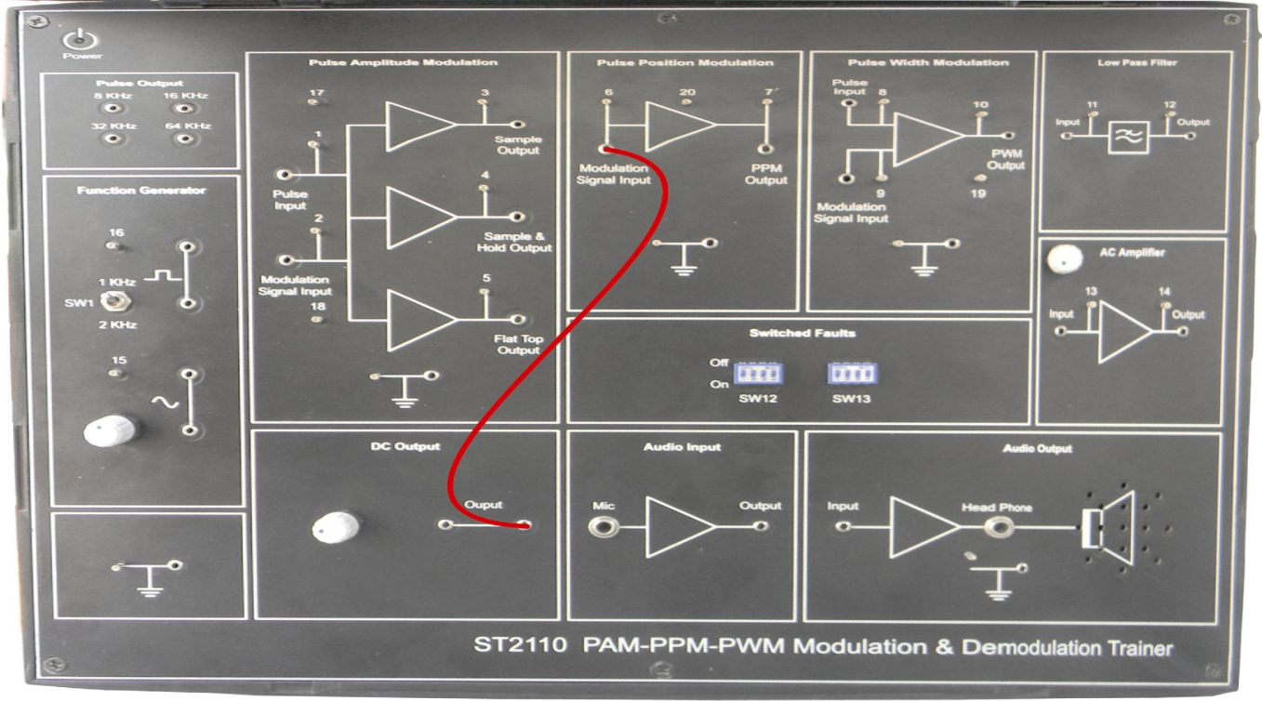**Related Wave Form:-**

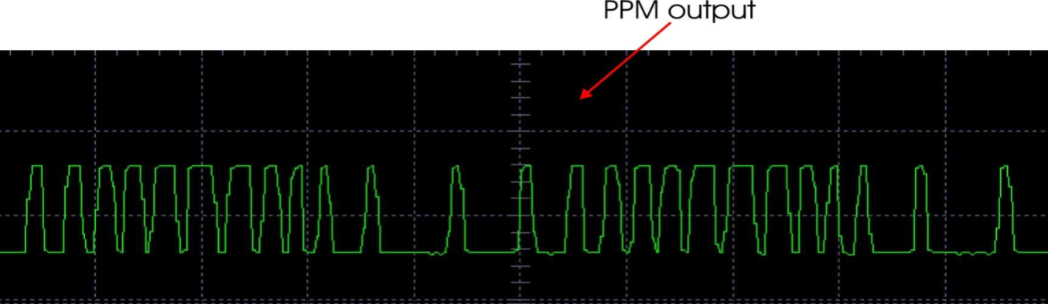

**FOR SINE WAVE INPUT:-**

**CIRCUIT DIAGRAM:-**

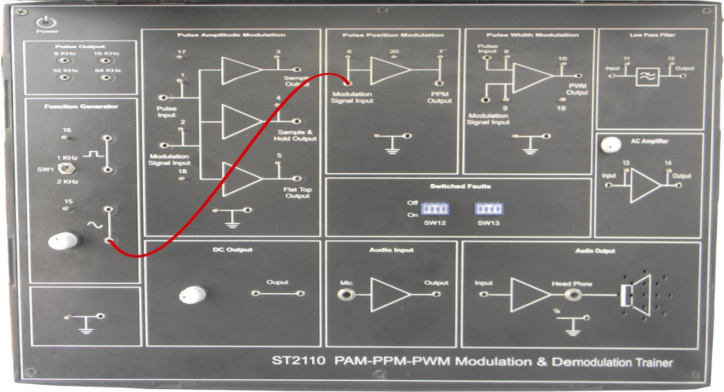

**PROCEDURE:-**

1. Connect the circuit as shown in Figure and also described below for clarity. a. Input of pulse position modulation blocks to sine wave output of FG block.
2. Switch ‘On’ the power supply & oscilloscope.
3. Keep the oscilloscope at 0.5mS / div, time base speed and in X-5 mode, and observe the pulse position modulated waveform at the pulse position modulation block output.
4. Vary the amplitude of sine wave and observe the pulse position modulation, keep the amplitude preset in center. Here you can best observe the pulse modulation.
5. Switch ‘On’ fault No. 1, 2, & 6 one by one & observe their effects in pulse position modulation output and try to locate them.
6. Switch ‘Off’ the power supply.

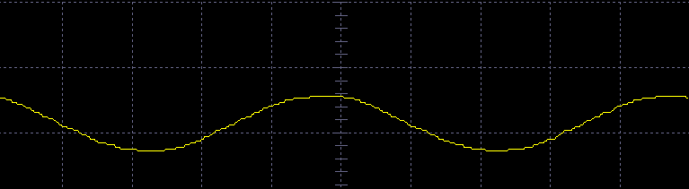

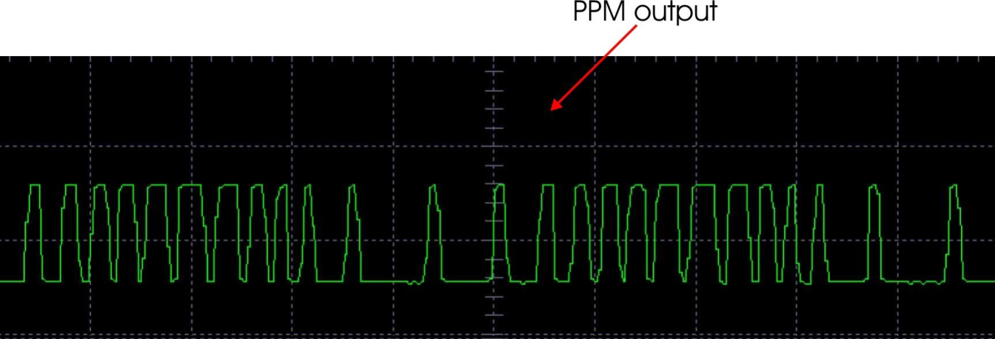

1. **Study of PWM using different Sampling Frequency.**

**APPARATUS REQUIRED:-**

1. ST2110 with power supply cord.
2. CRO with connecting probe.
3. Connecting cords.

**THEORY:-**

In pulse width modulation of pulse amplitude modulation is also often called PDM (pulse duration modulation) and less often, PLM (pulse length modulation). In this system, as shown in Figure, we have fixed amplitude and starting time of each pulse, but the width of each pulse is made proportional to the amplitude of the signal at that instant.



**a) Analog signal, s(t). (b) Pulse-amplitude modulation. (c) Pulse-width modulation (d) Pulse-position modulation.**

there may be a sequence of signal sample amplitudes of (say) 0.9, 0.5, 0 and -0.4V. These can be represented by pulse widths of 1.9, 1.5, 1.0 and 0.6μs respectively. The width corresponding to zero amplitude was chosen in this system to be 1.0μs, and it has been assumed that signal amplitude at this point will vary between the limits of + 1 V (width = 2μs) and -1 V (width = 0μs). Zero amplitude is thus the average signal level, and the average pulse width of 1μs has been made to cores to it. In this context, a negative pulse width is not possible. It would make the pulse end before it began, as it were, and thus throw out the timing in the receiver. If the pulses in a practical system have a recurrence rate of 8000 pulses per second, the time between the commencements of adjoining pulses is 106 /8000 = 125μs. This is adequate not only to accommodate the varying widths but also to permit time-division multiplexing. Pulse width modulation has the disadvantage, when compared with pulse position modulation, which will be treated next, that its pulses are of varying width and therefore, of varying power content. This means that the transmitter must be powerful enough to handle the maximum-width pulses, although the average power transmitted is perhaps only half of the peak power. On the other hand, pulse width modulation still works if synchronization between transmitter and receiver fails, whereas pulse-position modulation does not, as will be seen.

**CIRCUIT DIAGRAM:-**

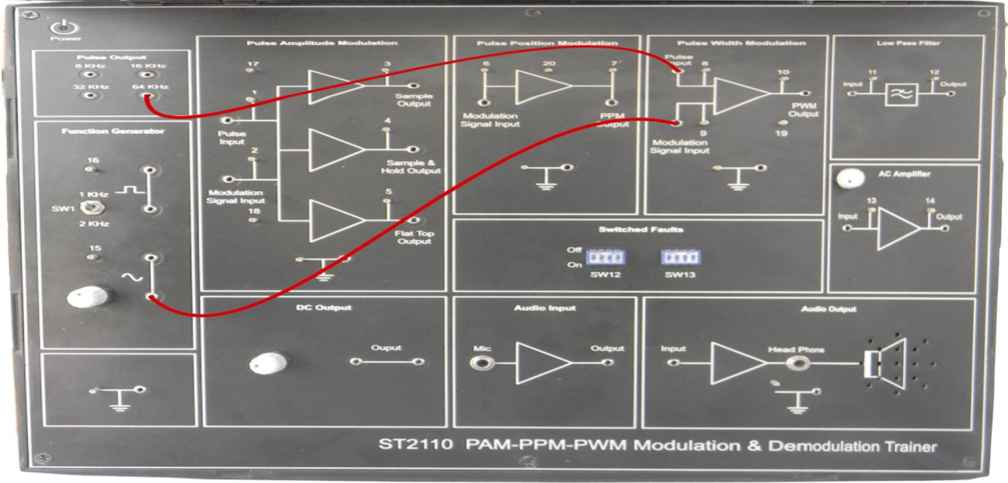

**PROCEDURE:-**

1. Connect the circuit as shown in Figure and also described below for clarity.

a. 1 KHz sine wave output of function generator block to modulation input of PWM block

b. 64 KHz square wave output to pulse input of PWM block.

1. Switch ‘On’ the power supply & oscilloscope.
2. Observe the output of PWM block.
3. Vary the amplitude of sine wave and see its effect on pulse output.
4. Vary the sine wave frequency by switching the frequency selector switch to 2 KHz.
5. Also, change the frequency of the pulse by connecting the pulse input to different pulse frequencies viz. 8 KHz, 16 KHz, 32 KHz and see the variations in the PWM output.
6. Switch ‘On’ fault No. 1, 2, & 5 one by one & observes their effect on PWM output and tries to locate them.
7. Switch ‘Off’ the power supply.

**EXPERIMENT NO-3**

**AIM:-**

**Study of PCM Transmitter and Receiver.**

**APPARATUS REQUIRED:-**

1. ST2103 trainer with power supply cord.
2. Oscilloscope with connecting probe.
3. Connection cords.

**THEORY:-**

The ST2103 & 2104, TDM PCM transmitter & receiver trainer demonstrates the basic scheme used to transmit an information signal using coding technique. It covers very basic concepts like role of sample Amplifier, Analog to digital conversion Pseudo random synch code generator, Digital to analog conversion, Pseudo random synch code detector of sampling pulse while transmitting a signal. It also demonstrates signal recovery using low pass filters of different orders.

**Steps in Pulse Code Modulation:-**

**Sampling:-**

The signals which are required to be transmitted as information is known as information signal and in the case of voice communication this will be a continuously changing signal containing speech information. The aim of the kit is to transmit the signals in digital form and is to reproduce this information signal in analog form at the receiving end of the communication system with the help of sampling and reconstruction trainer. In the exercises to follow, you will simulate audio signal by a 1 KHz test signal provided On-board. The repetitive, non-changing waveform does not contain information. Provided the frequency of the test-signal lies within the frequency range which an information signal will occupy, a test signal of this type can be extremely helpful in system analysis and testing The voice signals are limited to the range 300 Hz to 3.4 KHz, a 1 KHz frequency fits conveniently in this range and can be used to demonstrate and test many techniques used in communication system. Theory of sampling: The signals we use in the real world, such as our voice, are called "analog" signals. To process these signals for digital communication, we need to convert analog signals to "digital" form. While an analog signal is continuous in both time and amplitude, a digital signal is discrete in both time and amplitude. To convert continuous time signal to discrete time signal, a process is used called as sampling. The value of the signal is measured at certain intervals in time. Each measurement is referred to as a sample.

**PRINCIPLE OF SAMPLING:-**

Consider an analogue signal x(t) that can be viewed as a continuous function of time, as shown in figure. We can represent this signal as a discrete time signal by using values of x(t) at intervals of nTs to form x(nTs) as shown in figure. We are "grabbing" points from the function x(t) at regular intervals of time, Ts, called the sampling period.

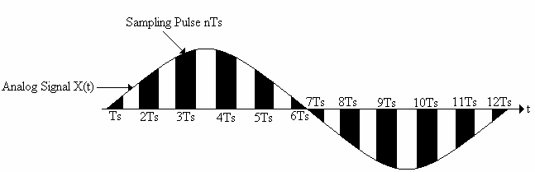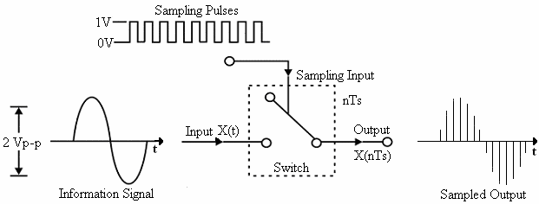

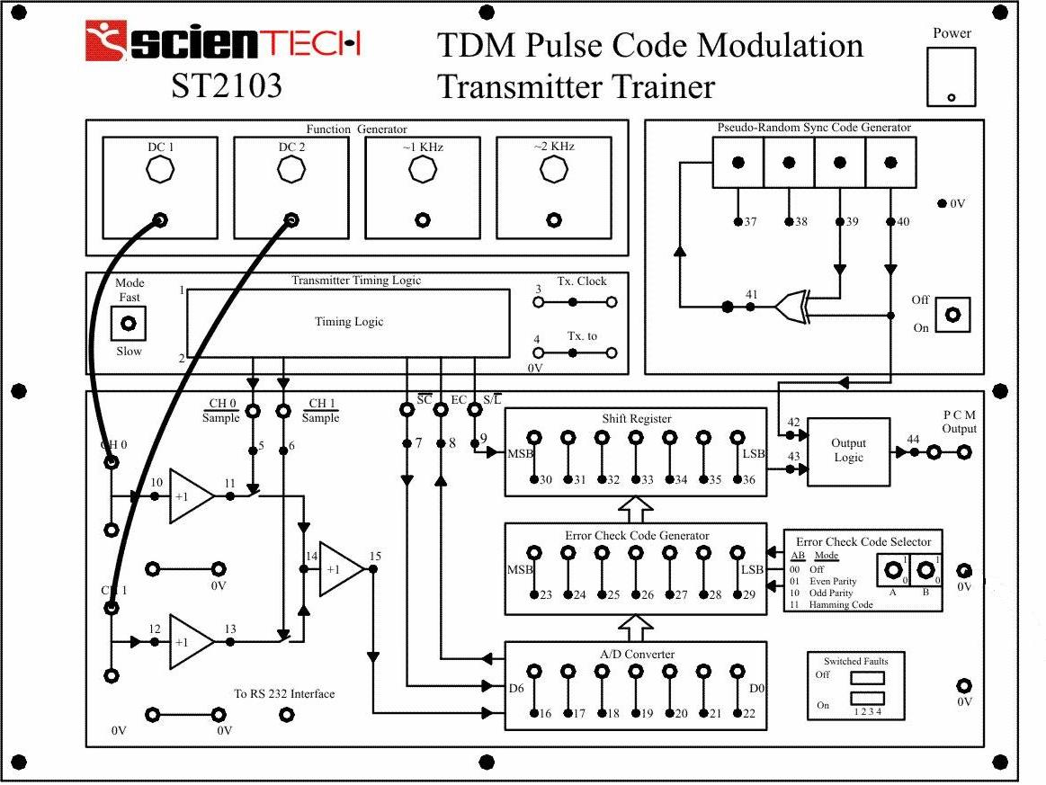Figure depicts the sampling of a signal at regular interval (period) t= nTs where n is an integer. The sampling signal is a regular sequence of narrow pulses δ (t) of an amplitude. Figure shows the sampled output of narrow pulses δ (t) at regular interval of time.

**CIRCUIT DIAGRAM:-**

**PROCEDURE:-**

A. Initial set up for trainer ST2103:

Mode Switch Position : FAST position.

Function generator setting:

DC l & DC 2 amplitude controls : fully clockwise direction.

1 KHz & 2 KHz signal levels : 10 V peak -peak.

Pseudo random sync code generator switch : OFF position.

Error check code selector switches A & B : A = 0 & B =0 Position ('Off' Mode).

All switched faults : OFF position.

1. Make the following connections as shown in figure.
2. I. DC 1 TO CH 0
3. II. DC 2 TO CH 1
4. Turn ‘On’ the power supply and oscilloscope. Adjust the DC1 amplitude control such that the voltage measured at TP10 (CH 0) with the help of DMM / oscilloscope is + 3 Volts. Adjust the DC 2 amplitude control so that the voltage at TP12 (CH 1) is 2 V.
5. The LED outputs of A/D Converter & shift register are a combination of the two input voltages. Also since the trainer is working in fast mode, it is impossible to detect the code.
6. As stated earlier, the two channels are sampled at different time. Approximately, after 10 seconds, when the system has settled down to slow mode, observe the LEDs of A/D converter Block. Notice that a particular combination of LEDs is lit in the A/D converter Block for approximately 7 seconds. These LEDs represent the latched output from the A/D Converter for every sample of CH 0 & CH 1 Channels. Note the output of the A/D Converter, Note: You may find the A/D Converter's output may not be identical every time you switch the circuit from fast to slow mode for the same DC Control setting. This is due to the slight change in voltage at Sample / Hold circuit at the time of switching. However the change in code will only be 1 Bit.
7. The parallel data from the A/D Converter is then loaded in the shift register which converts in serial output. Connect the oscilloscope at following points :

a) Oscilloscope channel 1 to TX. Clock output (TP3)

b) Oscilloscope channel 2 to S/L test point (TP9)

c) External trigger to TX. to output (TP4) You may have to adjust the oscilloscope trigger levels to obtain a stable display.

1. Observe the interdependence of S/L, TX clock output and the shift register outputs as shown by their respective LEDs. Record the waveforms. The timing diagram for the process is shown in figure.

**CONCLUSION:-**

As the controlling signals are properly synchronized the output of the two input waveforms are also synchronized.

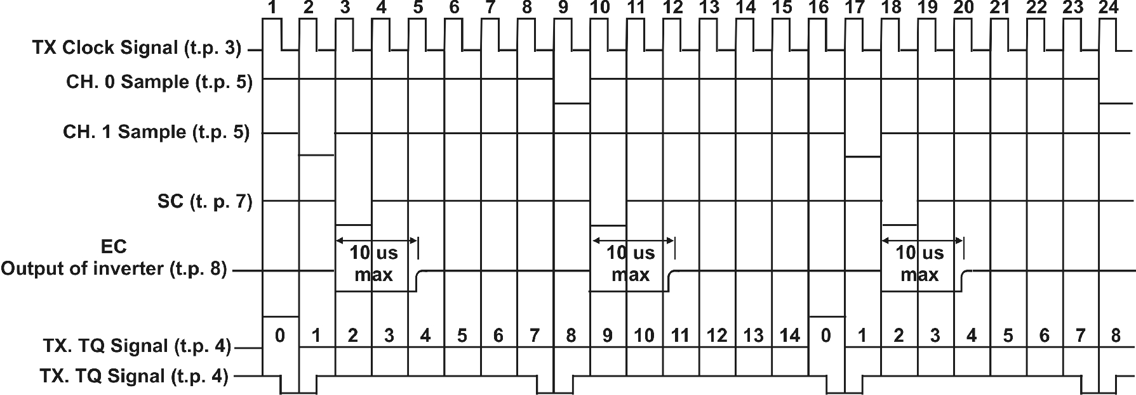

**System Timing Diagram**

**EXPERIMENT NO-4**

**AIM:-**

**Study Time Division Multiplexing (TDM) and De multiplexing.**

**APPARATUS REQUIRED:-**

1. ST2102 with power supply cord.
2. Oscilloscope with connecting probe.
3. Connecting cords.

**THEORY:-**

Multiplexing: A sampled signal consists of a train of pulses, where each pulse corresponds to the amplitude of the signal at the corresponding sampling time. The signal sent to line is modulated in amplitude and hence the name Pulse Amplitude Modulation (PAM). Multiplexing is the process of combining signals from different information sources so that they can be transmitted over a common channel. Multiplexing is advantageous in cases where it is impracticable and uneconomical to provide separate links for the different information sources. The price that has to be paid to acquire this advantage is in the form of increased system complexity and bandwidth. The two most commonly used methods of multiplexing are:

1. Frequency division multiplexing (FDM)
2. Time division multiplexing (TDM)

**Time Division Multiplexing:-**

Time division multiplexing is the process of combining the samples from different information signals, in time domain so that they can be transmitted over the common channel. The fact utilized in TDM technique is that there are large intervals between the message samples. The samples from the other sources can be placed within these time intervals. Thus every sample is separated from other in time domain. The time division multiplexing system can be simulated by two rotating switches, one at transmitter and the other at receiver. (See figure) The two wipers rotate and establish electrical contact with one channel at a time.

Each signal is sampled over one sampling interval and transmitted one after the other along a common channel. Thus part of message 1 is transmitted first followed by part of message 2, message 3 and then again message 1 so on. The switches connect the transmitter and the receiver to each of the channels in turn for a specific interval of time. In effect each channel is sampled and the sample is transmitted when the switches are in the channel 1 position, channel 1 forms a PAM channel with an LPF for reconstruction, and so on for channels 2 and 3. The result is that the amplitudes samples from each channel share the line sequentially, becoming interleaved to form a complex PAM wave, as shown above. A major problem in any TDM system is the synchronization of the transmitter and receiver timing circuits. The transmitter and receiver must switch at the same time and frequency. Also SW1 must be in the channel 1 position when SW2 is in the channel 1 position, so that the switches must be synchronized in position also. In a system that uses analogue modulation (PAM) the time slots are separated by guard slots to 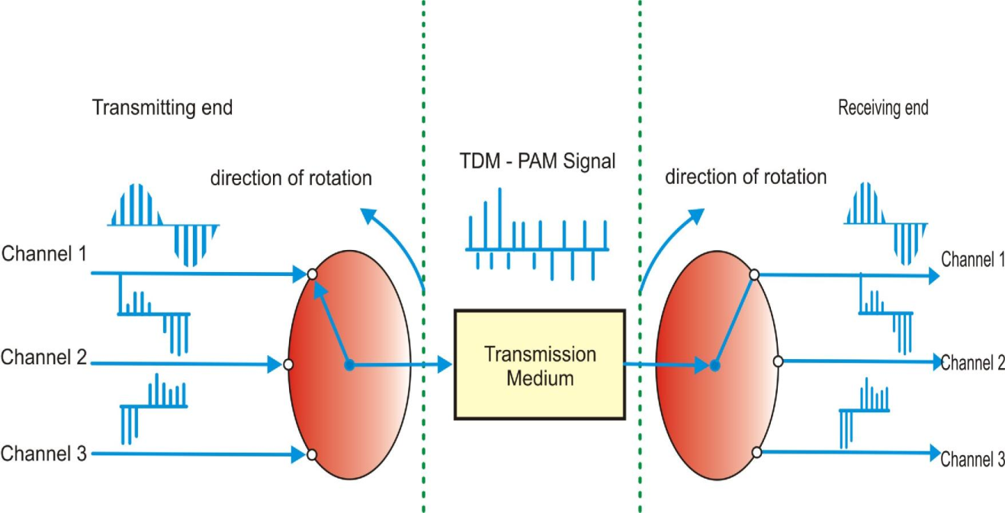prevent crosstalk between channels.

**Principle operation of TDM-PAM system**

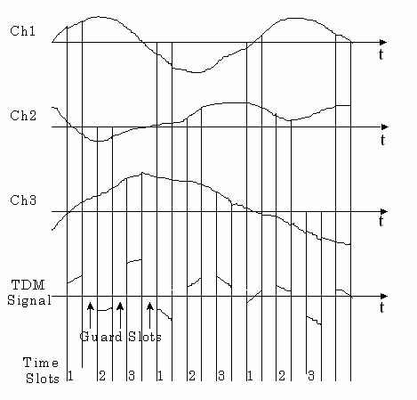

**Timing waveform of TDM-PAM system**

**CIRCUIT DIAGRAM:-**

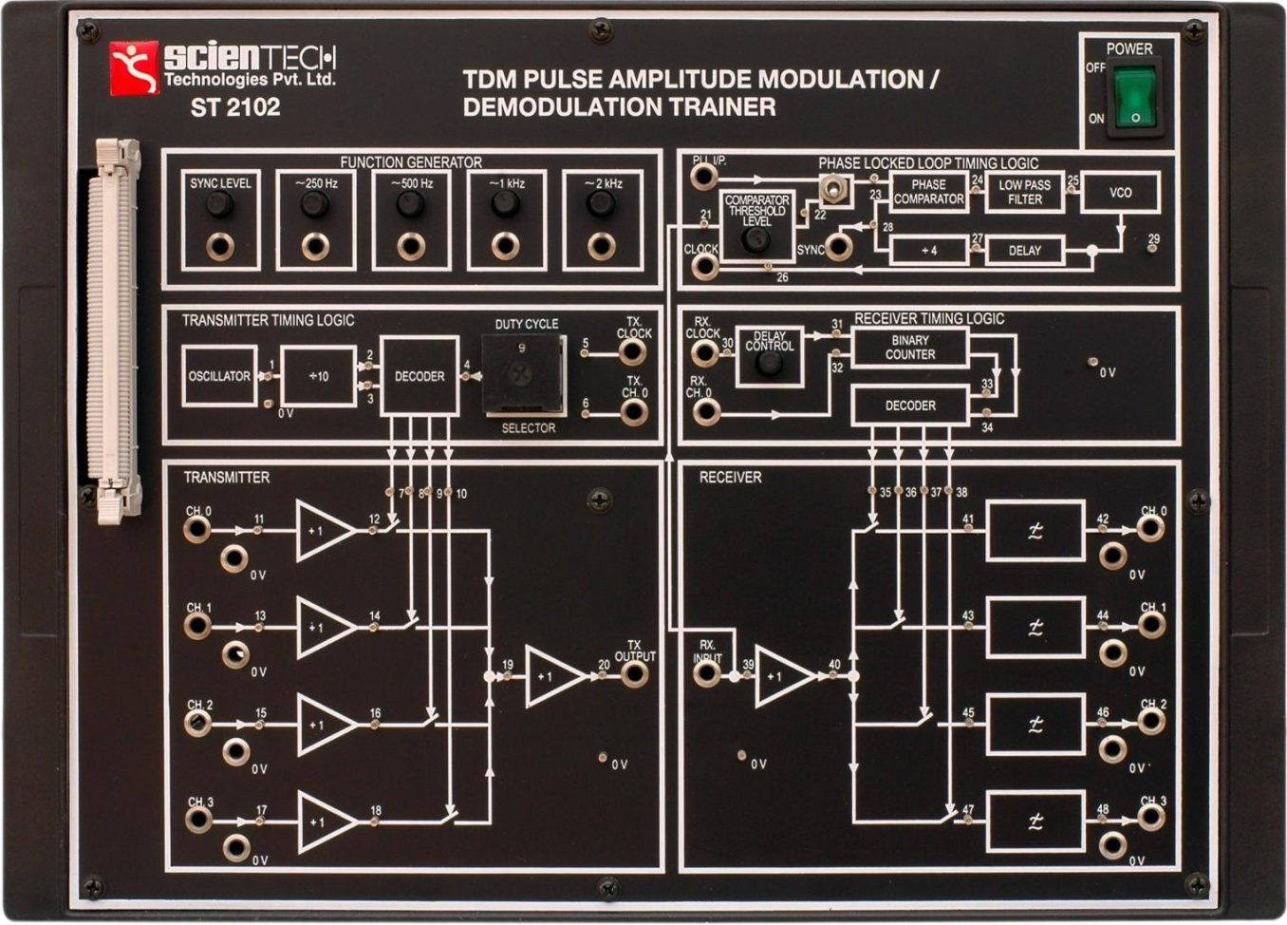

**PROCEDURE:-**

Initial Setup of Trainer.

Function Generator pot direction.

Anti clock wise Duty cycle Position.

Delay control.

Anti clockwise Comparator Threshold level.

Anti clockwise.

1. Connect the power cord to the trainer. Keep the power switch in ‘Off’ position.
2. Switch ‘On’ the trainer's power supply & Oscilloscope.
3. Connect BNC connector to the CRO and to the trainer’s output port.
4. Observe the clock signal (TP5) provided on Transmitter Timing Logic block on CRO. It will be a train of pulses having clock frequency of 64 KHz.
5. Display the clock signal (TP5) along with channel 0(TP6). Observe the relation between two signals.
6. Vary the Duty Cycle Selector switch and observe the variation in both signals (TP5 & TP6).
7. Observe the waveforms at TP7, 8, 9 & 10. Sketch the relative time graph between the waveforms observed at TP 5, 7, 8, 9 & 10.
8. With the same links, observe the waveform at Transmitter CH0 output (TP6) on channel 1 of the oscilloscope. 9. Observe the waveforms at TP7, 8, 9, & 10 on the other channel.
9. Plot the wave forms in time domain with reference to the Transmitter CH0 Signal.

**CONCLUSION:-**

1. The ‘On’ and ‘Off” time of Sync signal is changed as we vary the Duty Cycle Selector Switch.
2. The switching time is varying as we change duty cycle, so accordingly we can change sampling period of input signals.

**EXPERIMENT NO–5**

**AIM:-**

**Study of ASK PSK and FSK transmitter and receiver.**

1. **Study of ASK (Amplitude Shift Keying) Modulation and Demodulation.**

**APPARATUS REQUIRED:-**

ASK kit (Model No. ME 749-I), connecting probes, CRO.

**THEORY:-**

The binary ASK was one of the earliest forms of digital modulation used in wireless telegraphy. this simplest form of the digital modulation is no longer used widely in digital communication. Nevertheless it serves as a useful model which helps in understanding certain concepts. In an ASK system binary symbol 1 is represented by transmitting a sinusoidal carrier wave of fixed amplitude Ac and fixed frequency Fc for the bit duration Tb seconds whereas binary symbol is represented by switching of the carrier for Tb seconds. This signal can be generated simply by tuning the carrier of sinusoidal oscillator on end of for the prescribed period by the modulating pulse trend. For this reason, the scheme is also known as on-off scheme.

**CIRCUIT DIAGRAM:-**

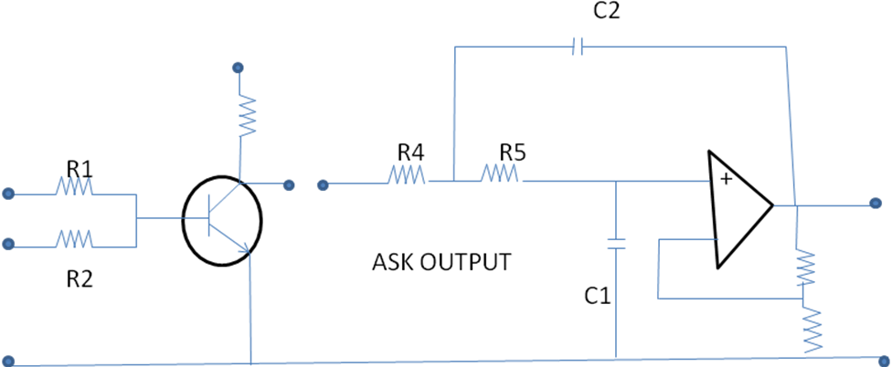

**PROCEDURE:-**

**FOR ASK MODULATION:-**

1. Connect the output of carrier wave generator (carrier output) to carrier input of ASK modulator & connect the modulating output to modulating input through petchcords.
2. Connect the CRO across output of ASK modulator.
3. Switch on the CRO as well as instrument.
4. Observe the output wave shape on CRO.
5. Change the amplitude & frequency of modulating signal & observe corresponding effect on ASK modulated wave. set the output shape (Ask modulated) through offset potentiometer provided on the front panel.

**FOR ASK DEMODULATION:-**

1. Connect the output of ASK modulator to the input of demodulator through petchcord.
2. Connect CRO probe across output of demodulator.

Observe the demodulated (square wave) shape on CRO. We will observe that the demodulated output is of same frequency as the modulated signal with little distortion.

**PRECAUTIONS:-**

1. Check the cont unity of the connecting probes.
2. Handle the CRO properly.
3. **Study of PSK (Phase Shift Keying) Modulation and Demodulation.**

**APPARATUS REQUIRED:-**

PSK Kit (Model No. ME 750-I), connecting probes, CRO.

**THEORY:-**

Digital communication became important with the expansion of the use of the computers and data processing and have continue to develop in to a major industry providing the interconnection of computer peripherals and transmission of data between distance sides. PSK is a relatively new system in which carrier may be phase shifted by 90° for a mark and by minus 90° for a space. PSK has a number of similarities to FSK in many aspects, as in FSK, frequency of the carrier is shifted according to modulating square wave.

**CIRCUIT DIAGRAM:-**

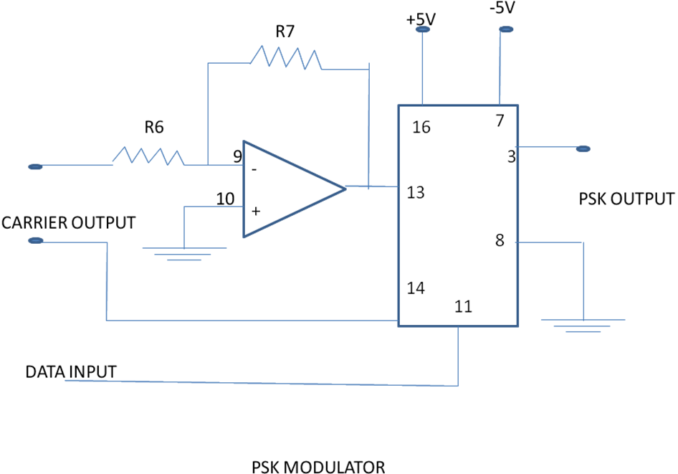

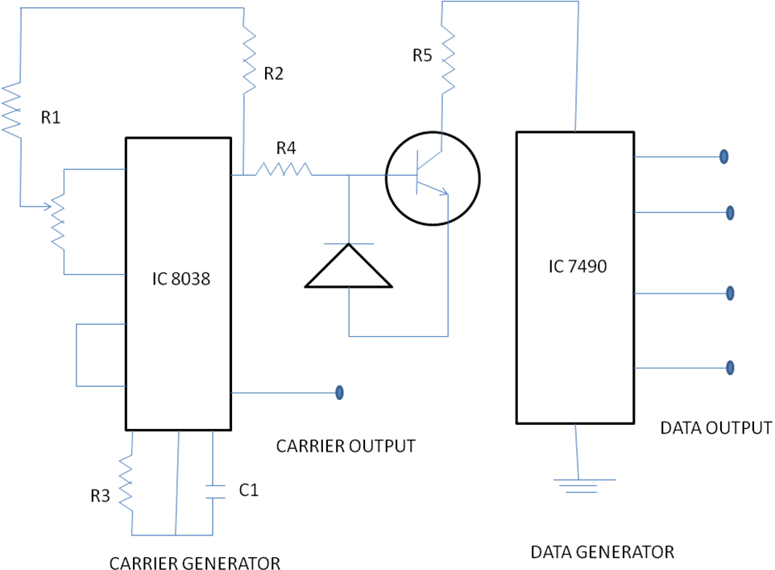

**PROCEDURE:-**

**FOR PSK MODULATION:-**

1. Connect the carrier Output of the carrier wave generator (IC 8038) to carrier input of PSK modulator through patch cords. Also connect any data output from the data outputs of the data generator to the data input of the PSK modulator.
2. Connect the channel 1 of CRO across output of PSK. And channel 2 across data input on a dual trace oscilloscope.
3. Switch on the instrument using ON/OFF toggle switch provided on the front panel.
4. Observe the output wave shape on CRO.
5. Change the data inputs and observe the PSK output on CRO.

**FOR PSK DEMODULATION:-**

1. Connect the output of PSK to the demodulator input through patch cord.
2. Connect the carrier to the carrier input of the PSK demodulator.
3. Connect the channel 1 of CRO across output of demodulator.
4. Observe the demodulated output on CRO (it will be same as data input applied in the modulated in the modulator section).

**PRECAUTIONS:-**

1. Check the cont unity of the connecting probes.
2. Handle the CRO properly.
3. **Study of Frequency Shift Keying.**

**APPARATUS REQUIRED:-**

Data generator, FSK modulation kit, CRO and connecting leads.

**THEORY:-**

FSK is one of the basic modulation techniques for the transmission of digital data .If the frequency of the sinusoidal carrier is switched depending upon the input digital signal , then it is known as frequency shift keying. As the amplitude remains constant in FSK, so the effect of non-linear ties, noise interference is minimum on digital detection. So FSK is preferred over ASK.

Frequency shift keying consists of shifting of frequency of carrier from a mask frequency to a space frequency according to the base band digital signal Frequency shift keying is identical to modulating an FM carrier with a binary digital signal In an FSK system, two sinusoidal carrier waves of the same amplitude Ac but different frequencies fc1 and fc2 are used to represent binary symbols 1and 0 respectively. It can be easily verified that binary FSK waveform is a superposition of two binary ASK waveforms, one with a frequency fc1 and other with a frequency fc2. No discrete components appear in the signal spectrum of FSK signal. The main advantage of FSK lies in its easy hardware implementation.

**Generation of FSK signal:-**

The PSK signal can be generated by applying the incoming binary data to a frequency modulator. To the other input a sinusoidal carrier wave of constant amplitude Ac and frequency fc is applied. As the modulating voltages changes from one level to another, the frequency modulator output changes its frequency in the corresponding fashion.

**Detection of FSK signal:-**

FSK can be demodulated by using coherent and non-coherent detector. The detector based on coherent detection requires phase and timing synchronization. Non coherent detection can be done by using envelop detector.

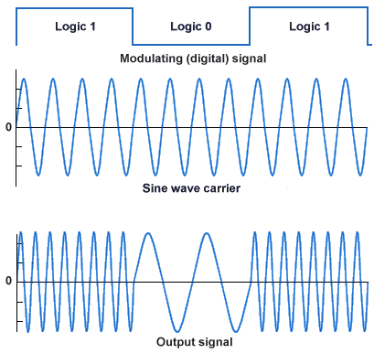

**RESULT:-**

FSK output is obtained on CRO.

**PRECAUTIONS:-**

1. Do not use open ended wires for connecting to 230 V power supply.
2. Before connecting the power supply plug in to socket, ensure power supply should be switched off
3. Ensure all connections should be tight before switching on the power supply.
4. Take the reading carefully.
5. Power supply should be switched off after completion of experiment

**EXPERIMENT NO. 6**

**AIM:**

**Study of AM modulation and Demodulation techniques (Transmitter and Receiver) Calculate of parameters.**

1. **To Generate Amplitude Modulated Wave and Determine the Percentage modulation.**

**APPARATUS REQUIRED:**

1. Amplitude Modulation and Demodulation Trainer

2. Function Generator

3. Oscilloscope

4. Connecting Wires

**THEORY:**

Modulation is defined as the process by which some characteristics of a carrier signal is varied in accordance with a modulating signal. The base band signal is referred to as the modulating signal and the output of the modulation process is called as the modulation signal.

Amplitude modulation is defined as the process in which is the amplitude of the carrier wave is varied about a means values linearly with the base band signal. The envelope of the modulating wave has the same shape as the base band signal provided the following two requirements are satisfied

(1) The carrier frequency fc must be much greater then the highest frequency components fm of the message signal m (t)

I.e. fc >> fm

(2) The modulation index must be less than unity. If the modulation index is greater than unity, the carrier wave becomes over modulated

**PROCEDURE:**

1 Switch on the trainer and check the O/P of carrier generator on oscilloscope.

2. Connect 1 KHz with 2 Volts A.F signal at AF I/P to the modulator circuit.

3. Connect the carrier signal at carrier I/P of modulator circuit. 4. Observe the modulator output signal at AM O/P by making necessary changes in A.F. Signal. 5. Vary the modulating frequency and amplitude and observe the effects on the modulated waveform.

6. The depth of modulation can be varied using the variable knob (potentiometer) provided at A.F. input.

7. The percentage of modulation or modulation factor can be calculated using the following formulas.

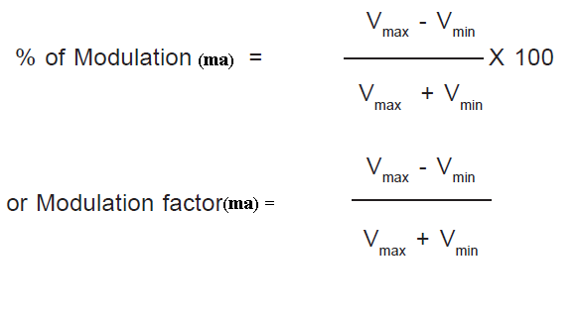



**Fig:- (1)Circuit Diagram For modulation**







**PRECAUTIONS:**

1. Connect the circuit as shown in the circuit diagram.

2. Apply the required voltages wherever needed.

3. Do not apply stress on the components.

**RESULT:**

Amplitude modulated wave generated and studied.

**(b)To Demodulate the Amplitude modulated wave using envelope detector.**

**APPARATUS REQUIRED:**

1. Amplitude Modulation and Demodulation Trainer

2. Function Generator

3. Oscilloscope

4. Connecting Wires

**THEORY:**

Demodulation is the act of extracting the original information-bearing signal from a modulated [carrier wave](http://en.wikipedia.org/wiki/Carrier_wave). A demodulator is an [electronic circuit](http://en.wikipedia.org/wiki/Electronic_circuit) (or [computer program](http://en.wikipedia.org/wiki/Computer_program) in a [software-defined radio](http://en.wikipedia.org/wiki/Software-defined_radio)) that is used to recover the information content from the modulated [carrier wave](http://en.wikipedia.org/wiki/Carrier_wave). There are many types of [modulation](http://en.wikipedia.org/wiki/Modulation) so there are many types of demodulators. The signal output from a demodulator may represent sound (an [analog](http://en.wikipedia.org/wiki/Analog_signal) [audio signal](http://en.wikipedia.org/wiki/Audio_signal)), images (an analog [video signal](http://en.wikipedia.org/wiki/Video_signal)) or [binary](http://en.wikipedia.org/w/index.php?title=Binary_signal&action=edit&redlink=1) data (a [digital signal](http://en.wikipedia.org/wiki/Digital_signal)).

These terms are traditionally used in connection with [radio](http://en.wikipedia.org/wiki/Radio) [receivers](http://en.wikipedia.org/wiki/Receiver_%28radio%29), but many other systems use many kinds of demodulators. For example in a [modem](http://en.wikipedia.org/wiki/Modem), which is a contraction of the terms [modulator](http://en.wikipedia.org/wiki/Modulator)/demodulator. a demodulator is used to extract a serial digital data stream from a [carrier signal](http://en.wikipedia.org/wiki/Carrier_signal) which is used to carry it through a [telephone line](http://en.wikipedia.org/wiki/Telephone_line), [coaxial cable](http://en.wikipedia.org/wiki/Coaxial_cable), or [optical fiber](http://en.wikipedia.org/wiki/Optical_fiber)

**There are two methods used to** [**demodulate AM signals**](http://en.wikipedia.org/wiki/Detector_%28radio%29)**.**

The [envelope detector](http://en.wikipedia.org/wiki/Envelope_detector) is a very simple method of demodulation. It consists of a [rectifier](http://en.wikipedia.org/wiki/Rectifier) (anything that will pass current in one direction only) or other non-linear that enhances one half of the received signal over the other, and a low-pass filter. The rectifier may be in the form of a single [diode](http://en.wikipedia.org/wiki/Diode), or may be [more complex](http://en.wikipedia.org/wiki/Plate_detector_%28radio%29). Many natural substances exhibit this rectification behavior, which is why it was the earliest modulation and demodulation technique used in radio. The filter is usually a [RC](http://en.wikipedia.org/wiki/RC_circuit) [low-pass](http://en.wikipedia.org/wiki/Low-pass_filter) type, but the filter function can sometimes be achieved by relying on the limited frequency response of the circuitry following the rectifier. The [crystal set](http://en.wikipedia.org/wiki/Crystal_radio_receiver) exploits the simplicity of AM modulation to produce a receiver with very few parts, using the crystal as the rectifier, and the limited frequency response of the headphones as the filter.

The [product detector](http://en.wikipedia.org/wiki/Product_detector) multiplies the incoming signal by the signal of a local oscillator with the same frequency and phase as the carrier of the incoming signal. After filtering, the original audio signal will result. This method will decode both AM and [SSB](http://en.wikipedia.org/wiki/Single-sideband_modulation), although if the phase cannot be determined a more complex setup is required.

An [AM](http://en.wikipedia.org/wiki/Amplitude_modulation) signal can be rectified without requiring a [coherent](http://en.wikipedia.org/wiki/Coherence_%28physics%29) demodulator. For example, the signal can be passed through an [envelope detector](http://en.wikipedia.org/wiki/Envelope_detector) (a [diode](http://en.wikipedia.org/wiki/Diode) [rectifier](http://en.wikipedia.org/wiki/Rectifier) and a [low-pass filter](http://en.wikipedia.org/wiki/Low-pass_filter)). The output will follow the same curve as the input [baseband](http://en.wikipedia.org/wiki/Baseband) signal.

**PROCEDURE:**

1. Switch on the trainer and check the O/P of carrier generator on oscilloscope.

2. Connect 1 KHz with 2 Volts A.F signal at AF I/P to the modulator circuit.

3. Connect the carrier signal at carrier I/P of modulator circuit. 4. Observe the modulator output signal at AM O/P Spring by making necessary changes in A.F. Signal. 5. Vary the modulating frequency and amplitude and observe the effects on the modulated waveform.

6. The depth of modulation can be varied using the variable knob (potentiometer) provided at A.F. input.

7. The percentage of modulation or modulation factor can be calculated using the following formulas.



8. Find the value of R from fm=1/ (2*Pi*R*C) , C=0.1μF

9. Connect the circuit diagram as shown in Fig.

10. Feed the AM wave to the demodulator circuit and observe the output

11. Note down frequency and amplitude of the demodulated output waveform.

12. Draw the demodulated wave form.



**Fig:- Circuit Diagram For Demodulation:**



**PRECAUTIONS:**

1. Connect the circuit as shown in the circuit diagram.

2. Apply the required voltages wherever needed.

3. Do not apply stress on the components.

**RESULT:**

Original baseband signal recovered from Amplitude modulated wave.

**EXPERIMENT NO -7**

**AIM:**

**Study of FM modulation and demodulation (Transmitter and Receiver) & Calculation of parameters.**

1. **To generate frequency modulated signal and determine the modulation index and Bandwidth.**

**APPARATUS REQUIRED:**

1. Frequency Modulation and Demodulation Trainer

2. Function Generator

3. Oscilloscope

4. Connecting Wires

**THEORY:**

The process, in which the frequency of the carrier is varied in accordance with the Instantaneous amplitude of the modulating signal is called “Frequency Modulation”. The FM signal is expressed as where Ac is amplitude of the carrier signal; *f c* is the carrier frequency β is the modulation index of the FM wave



**Circuit Diagram for Frequency Modulator**

**PROCEDURE:**

1. Switch on the FM experimental board.

2. Connect Oscilloscope to the FM O/P and observe that carrier frequency at that point without any A.F. input.

3. Connect around 7KHz sine wave (A.F. signal) to the input of the frequency modulator (At AF input).

4. Now observe the frequency modulation output on the 1st channel of on CRO and adjust the amplitude of the AF signal to get clear frequency modulated wave form.

5. Vary the modulating frequency (A.F Signal) and amplitude and observe the effects on the modulated waveform.

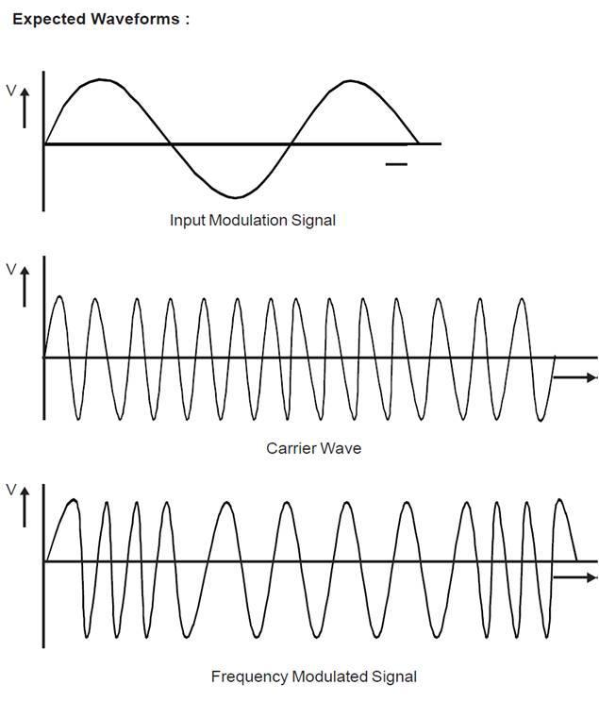

**PRECAUTIONS:**

1. Connect the circuit properly.

2. Apply the required voltages wherever needed.

3. Do not apply stress on the components.

**RESULT:**

Frequency of the Carrier signal varied according to the baseband signal and waveform observed.

1. **To Demodulate a Frequency Modulated signal using FM detector.**

**APPARATUS REQUIRED:**

1. Amplitude Modulation and Demodulation Trainer

2. Function Generator

3. Oscilloscope

4. Connecting Wires

**THEORY:**

Demodulation is the act of extracting the original information-bearing signal from a modulated [carrier wave](http://en.wikipedia.org/wiki/Carrier_wave). A demodulator is an [electronic circuit](http://en.wikipedia.org/wiki/Electronic_circuit) (or [computer program](http://en.wikipedia.org/wiki/Computer_program) in a [software-defined radio](http://en.wikipedia.org/wiki/Software-defined_radio)) that is used to recover the information content from the modulated [carrier wave](http://en.wikipedia.org/wiki/Carrier_wave).

There are many types of [modulation](http://en.wikipedia.org/wiki/Modulation) so there are many types of demodulators. The signal output from a demodulator may represent sound (an [analog](http://en.wikipedia.org/wiki/Analog_signal) [audio signal](http://en.wikipedia.org/wiki/Audio_signal)), images (an analog [video signal](http://en.wikipedia.org/wiki/Video_signal)) or [binary](http://en.wikipedia.org/w/index.php?title=Binary_signal&action=edit&redlink=1) data (a [digital signal](http://en.wikipedia.org/wiki/Digital_signal)).

The process, in which the frequency of the carrier is varied in accordance with the Instantaneous amplitude of the modulating signal is called “Frequency Modulation”. The FM signal is expressed as where *Ac* is amplitude of the carrier signal; *f c* is the carrier frequency β is the modulation index of the FM wave.

In FM demodulation process we extract message signal from the FM modulated signal



**Circuit Diagram:**



**PROCEDURE:**

1. Switch on the FM experimental board.

2. Connect Oscilloscope to the FM O/P and observe that carrier frequency at that point without any A.F. input.

3. Connect around 7KHz sine wave (A.F. signal) to the input of the frequency modulator (At AF input).

4. Now observe the frequency modulation output on the 1st channel of on CRO and adjust the amplitude of the AF signal to get clear frequency modulated wave form.

5. Vary the modulating frequency (A.F Signal) and amplitude and observe the effects on the modulated waveform.

6. Connect the FM o/p to the FM i/p of De-modulator.

7. Vary the potentiometer provided in the demodulator section.

8. Observe the output at demodulation o/p on second channel of CRO.

9. Draw the demodulated wave form



**PRECAUTIONS:**

1. Connect the circuit properly.

2. Apply the required voltages wherever needed.

3. Do not apply stress on the components.

**RESULT:**

Original baseband signal recovered from Frequency modulated wave.

**EXPERIMENT NO - 8**

**AIM:**

**To Construct and Verify Pre-emphasis and De-emphasis and Plot the Waveforms.**

**APPARATUS REQUIRED:**

1. Resistors (10 K-2, 47K, 75K, 1K)

2. Capacitors (22μF, 0.1μ-2,)

3. Transistor BC107

4 Function generators

5. CRO

6. Connecting Wires

7. RPS (15V)

8. Connecting wires.

**THEORY:**

The noise has a effect on the higher modulating frequencies than on the lower ones. Thus, if the higher frequencies were artificially boosted at the transmitter and correspondingly cut at the receiver, an improvement in noise immunity could be expected, thereby increasing the SNR ratio. This boosting of the higher modulating frequencies at the transmitter is known as pre-emphasis and the compensation at the receiver is called de-emphasis

**CIRCUIT DIAGRAM:**



**Pre-Emphasis:**



**De-Emphasis:**

**PROCEDURE:**

1. Connect the circuit as per circuit diagram as shown in Fig.

2. Apply the sinusoidal signal of amplitude 20mV as input signal to pre emphasis circuit.

3. Then by increasing the input signal frequency from 500Hz to 20 KHz, observe the output voltage (VO) and calculate gain 20 log (vo/vi).

4. Plot the graph between gain Vs frequency.

5. Repeat above steps 2 to 4 for de-emphasis circuit (shown in Fig.2). by applying the sinusoidal signal of 5V as input signal.

**TABULAR FORM:**

**PRE-EMPHASIS:**

|  |  |  |  |  |
| --- | --- | --- | --- | --- |
| S.NO. | **Frequency (Hz)** | **I/P Voltage**  **Vi** | **O/P Voltage**  **Vo** | **Gain in dB**  **20log(Vo /V i)** |
|  |  |  |  |  |

**DE-EMPHASIS:**

|  |  |  |  |  |
| --- | --- | --- | --- | --- |
| S.NO. | **Frequency (Hz)** | **I/P Voltage**  **Vi** | **O/P Voltage**  **Vo** | **Gain in dB**  **20log(Vo /V i)** |
|  |  |  |  |  |

**MODEL GRAPH**



**RESULT:-**

Thus the pre-emphasis and de-emphasis characteristics are studied

**EXPERIMENT NO–9**

**AIM:-**

**Study of Super-heterodyne Receiver and Characteristics of Radio Receiver.**

**THEORY:-**

In super heterodyne radio receivers, the incoming radio signals arc intercepted by the antenna arid converted into the corresponding currents and voltages. In the receiver, the incoming signal frequency is mixed with a locally generated frequency. The output of the mixer consists of the sum and difference of the two frequencies. The mixing of the two frequencies is termed heterodyning. Out of the two resultant components of the mixer, the sum component is rejected and the difference component is selected. The value of the difference frequency component varies with the incoming frequencies, if the frequency of the local oscillator is kept constant. It is possible to keep the frequency of the difference components constant by varying the frequency of the local oscillator according to the incoming signal frequency. In this case, the process is called Super heterodyne and the receiver is known as a super heterodyne radio receiver.

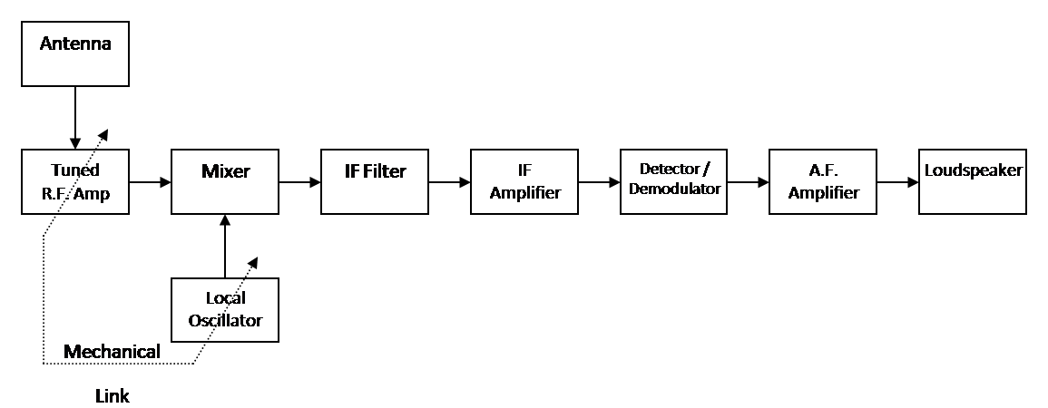

**FIG:- BLOCK DIAGRAM OF SUPERHETERODYNE RECEIVER**

**Antenna**

As with all radio stations, the antenna will pick up the electromagnetic radio waves from the atmosphere and convert these into very small electrical currents.

**Tuned R.F. Amplifier.**

This block amplifies the very small currents created in the antenna, to improve the sensitivity of the radio receiver, in the same way that it was used in the TRF radio.

**Local Oscillator**

A new addition to the superheteradio. This is a sine wave generator which is mechanically linked to the tuning capacitor. This ensures that it always produces a frequency at a fixed amount above the resonant frequency of the tuned amplifier. This is typically in the range 450 kHz to 480 kHz.

**Mixer**

Again a new addition to the super heterodyne radio, but is the critical addition, as it combines the received modulated radio frequency carrier (fc) from the R.F.Amplifier, and the Local Oscillator (fo). The output of the mixer produces at its output four different frequency signals containing the following frequencies, fc, fo-fc, fo+fc, fo. Three of these frequencies fc, fo-fc, fo+fc are amplitude modulated signals each containing all the information about the original audio signal. The only one that does **not** contain the original signal is fo, the local oscillator frequency which is a pure sine wave. The most important of these is fo-fc because irrespective of the carrier frequency that is tuned in, this frequency will always be the same, since the output of the local oscillator tracks the carrier frequency tuned in. This modulated frequency is called the **intermediate frequency (I.F.)** and contains the audio signal from the original radio station no matter what station is tuned in.

**IF Filter**

The I.F. Filter is a fixed range band pass filter with very high selectivity, specifically designed to pass only the intermediate frequency. It is this which gives the super heterodyne receiver it’s big advantage because no matter what radio station is tuned in, it will be transferred by the mixer to the intermediate frequency and this highly specialised band pass filter will be able to select this single frequency from the four produced by the mixer every time with perfect rejection of the others.

**IF Amplifier**

This stage provides extra amplification for the signal after the IF filter, and again is carefully designed to provide maximum gain at the IF frequency. The combined effect of the IF filters and IF amplifier gives the super heterodyne receiver its excellent selectivity. Commercial radio receivers may have several pairs of IF filters and amplifiers all tuned to an identical IF Frequency. This is often referred to as the IF Strip.

**Detector / demodulator.**

As in the simple radio receiver, the detector/demodulator block contains the diode and RF filter to produce the non-zero signal, and remove the remaining RF carrier.

**AF Amplifier**

The recovered audio signal is now amplified so that it can provide a meaning full signal to the loudspeaker.

**Loudspeaker**

Converts the amplified audio signal into sound.

**RESULT:-**Study of Super-heterodyne Receiver Completed.

**EXPERIMENT NO -10**

**AIM: -** **To study the operation of AGC and AFC.**

**THEORY:**

## Automatic Gain Control (AGC)

To control the gains of the amplifiers of the system, AGC is employed. The AGC voltage is used to keep the volume of the receiver constant to the level set by the listener. The output of the second IF amplifier is also given to the AGC detector.

The AGC detector produces a dc voltage, called the AGC bias voltage, which is proportion to the carrier strength of the received signal. The signal is also amplified by the AG amplifier before being detected to generate the AGC bias voltage. The AGC bias voltage generated is applied to the RF amplifier and first IF amplifier, to control their gains.

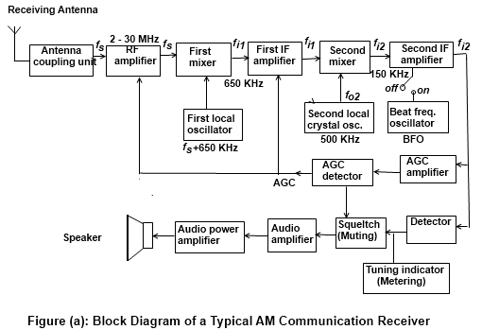

In communication receivers, the simple AGC technique discussed in AM receivers is not employed. This is because the simple AGC also reduces the gain of the amplifiers for the weak signals. In communication receivers, improved AGC techniques are used so that the weak signals are satisfactorily processed. The two techniques or AGC that are employed in communication receivers are:

* Delayed ACC
* Auxiliary AGC

### Delayed AGC

In delayed AGC, the AGC remains inoperative below a predetermined input carrier voltage. If predetermined level, it is considered a weak signal. The received signal strength is below the predetermined level, it is considered a weak signal. The AGC bias voltage is applied to the RF and IF amplifiers only if the level or input carrier voltage goes above this predetermined level. In other words, the AGC is delayed in applying the bias voltage to the amplifiers the bias voltage to the amplifier for a certain predetermined level.

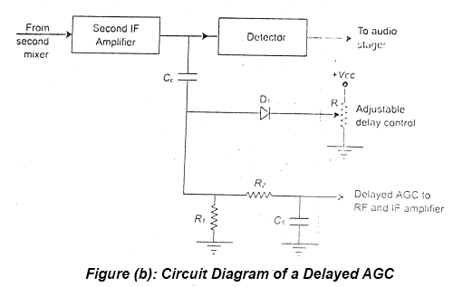

A typical circuit diagram of a delayed AGC is illustrated in Figure (b). In delayed AGC, the output of the last IF amplifier, which is the second IF amplifier, is taken through a coupling capacitor, Cc. This is applied to a diode, D1. The cathode of diode D1 is provided with a positive dc voltage, Vdc, through a variable resistor, R. This sets the predetermined level up to which the AGC is not to be applied. If the received signal is weak, the anode voltage of the diode is less than the cathode voltage, and is reverse-biased. This results in the diode not conducting. The received signal thus goes to R1, R2, and C1 networks, as shown in Figure (b). This is an AC signal and passes through C1. Thus, no dc voltage is available for AGC and the amplifiers operate at their usual gains.

When a strong signal is received, the anode voltage goes above the cathode voltage of the diode, and the diode starts conducting. The signal, passed to capacitor C1 in this condition, gets negative peaks and filters them. This results in a constant negative voltage, which is used as a delayed AGC and applied, to the RF and IF amplifiers. The variable resistor, R can adjust the level of delay AGC. This control is given at the panel of the receiver so that the operator can adjust the delayed AGC level according to the signal conditions. If a weak signal is received, then the operator can adjust it so that no AGC is applied.

#### AGC Characteristics Curves

A comparison between simple AGC and delayed AGC is shown in Figure (c). A curve is also drawn for an ideal AGC.

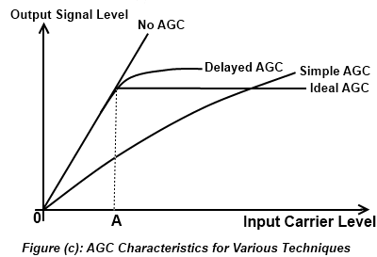

These curves are also compared with the generated when AGC is not applied. An ideal AGC provides a constant output signal level for all input carrier signals, after a particular input level, marked as A in Figure (c). Up to point A, the output level linearly increases with the input carrier signal. A simple AGC continuously increases with an increase in the input carrier signal. Thus, there is no control on the output signal level for a simple AGC. On the other hand, the characteristic curve for delayed AGC shows that it is very close to the ideal AGC.

### Auxiliary AGC

In communication receivers, an auxiliary AGC is provided in addition to the delayed AGC. The auxiliary AGC becomes operative for very strong signals. The auxiliary AGC circuit includes only one diode, which is connected between the collector of the first IF amplifier, Q3, and the collector of the converter, Q4, as shown in Figure (d).

The anode of the diode is connected to the collector of the IF amplifier and the cathode is connected to the collector of the convertor. When the signal is not strong the diode is reverse biased and does not affect the normal operation of the circuit. When a very strong signal is received, the diode becomes forward biased and starts conducting. The diode resistances lowers and it loads the first IFT and capacitor C3, as shown in Figure (d). This circuit is connected to the base of first 1F amplifier, and its gain reduces due to the loading of IFT1 and C3. This accordingly reduces the output signal level. The auxiliary AGC provides another means to reduce the gain of the IF amplifier in the presence of strong signals.

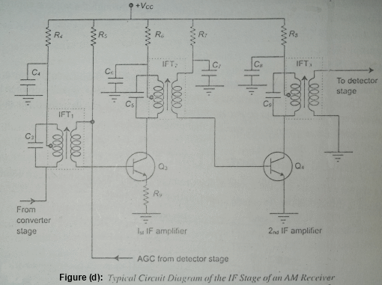

**Automatic Frequency Control AFC**

circuits are used in situations where you must accurately control the frequency of an oscillator by some external signal. Basically, this type circuit does two things: It senses the difference between the actual oscillator frequency and the frequency that is desired and produces a control voltage proportional to the difference; it also uses the control voltage to change the oscillator to the desired frequency. AFC circuits are used to control the frequency of sinusoidal oscillators and no sinusoidal oscillators. Only sinusoidal AFC circuits will be covered here. AFC circuits are used in radio receivers, fm transmitters, and frequency synthesizers to maintain frequency stability. Figure (e) is a block diagram illustrating AFC operation in a receiver. Let’s run through the applicable parts of this block diagram.

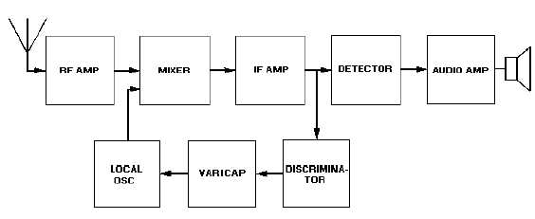

**Figure (e): Block diagram of receiver showing automatic frequency control.**

Figure (f) shows another widely used type of AFC and its circuitry. This type is commonly referred to as a BALANCED-PHASE DETECTOR or PHASE-DISCRIMINATOR. This circuit uses fixed capacitors and the varying conductance of the diodes to achieve a variable reactance.

As seen in the block diagram, an AFC circuit requires two sections, a frequency detector and a variable reactance. Our detector output is a dc control voltage proportional to the amount of frequency change. This dc voltage is applied directly to the oscillator. The phase inverter input signals are discriminated IF outputs fed to the two diodes 180 degrees out of phase.

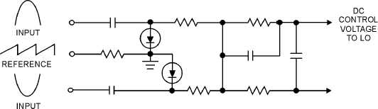

**Figure (f) Automatic frequency control (phase discriminator)**

A reference voltage is also applied to both diodes. The diodes are biased to conduct only during the peak portions of the input signals. Any change in oscillator frequency will alter the phase relationship between the saw tooth reference voltage and the incoming signals. If this happens, one diode will conduct more than the other and produce a control signal. This system remains unbalanced at all times because any change in frequency is instantaneously corrected. The network between the diodes and oscillator is essentially a low-pass filter. This filter prevents discriminator pulses from reaching the oscillator.

**EXPERIMENT NO -11**

**AIM:**

Study of phase modulation.

**APPARATUS REQUIRED:**

1. Phase modulation and Demodulation kit
2. CRO
3. Set of patching tips
4. AFO
5. DMM

**THEORY:**

Phase Modulation (PM) is another form of angle modulation. PM and FM are closely related to each other. In both the cases, the total phase angle θ of the modulated signal varies. In an FM wave, the total phase changes due to the change in the frequency of the carrier corresponding to the changes in the modulating amplitude.

In PM, the total phase of the modulated carrier changes due to the changes in the instantaneous phase of the carrier keeping the frequency of the carrier signal constant. These two types of modulation schemes come under the category of angle modulation. However, PM is not as extensively used as FM.

Phase modulation is defined as the process in which the instantaneous phase of the carrier signal is varied in accordance with the instantaneous amplitude of the modulating signal. In this type of modulation, the amplitude and frequency of the carrier signal remains unaltered after PM. The modulating, signal is mapped to the carrier signal in the form of variations in the instantaneous phase of the carrier signal.

o derive the equation of a PM wave, it is convenient to consider the modulating signal as a pure sinusoidal wave. The carrier signal is always a high frequency sinusoidal wave. Consider the modulating signal, em and the carrier signal ec, as given by, equation 1 and 2, respectively.

em = Em cos ωm t ------------(1)

ec = Ec sin ωc t ---------------(2)

The initial phases of the modulating signal and the carrier signal are ignored in Equations (1) and (2) because they do not contribute to the modulation process due to their constant values. After PM, the phase of the carrier will not remain constant. It will vary according to the modulating signal em maintaining the amplitude and frequency as constants. Suppose, after PM, the equation of the carrier is represented as:

e = Ec Sin θ ------------------(3)

Where θ, is the instantaneous phase of the modulated carrier, and sinusoid ally varies in proportion to the modulating signal. Therefore, after PM, the instantaneous phase of the modulated carrier can be written as:

θ = ωc t + Kp em -------------------(4)

Where, kp is the constant of proportionality for phase modulation.  
Substituting Equation (1) in Equation (4), yon get:

θ = ωc t + Kp Em Cos ωm t ---------------------(5)

In Equation (5), the factor, kpEm is defined as the modulation index, and is given as:

mp = Kp Em ------------------------(6)

where, the subscript p signifies; that mp is the modulation index of the PM wave. Therefore, equation (5) becomes

θ = ωc t + mp Cos ωm t ---------------------(7)

Substituting Equation (7) and (3), you get:

e = Ec sin (ωct + mp cos ωmt) --------------------(8)

Equation (8) is the final expression of the PM wave.

**PROCEDURE:**

1. Switch on the trainer kit.
2. Check the power supply to be +12,+5,-5v.
3. Study the circuit as per the circuit diagram.
4. Connect the AF input at the corresponding terminal.
5. IC XR2206 is provided to generate 100Khz carrier wave frequency.
6. With the help of CRO observe the PM output at the output terminal.
7. By increasing the 100K potentiometer in clockwise direction you will observing the change in the phase modulation output, which in turn you can able to calculate the variable change in the “MODULATION INDEX”.

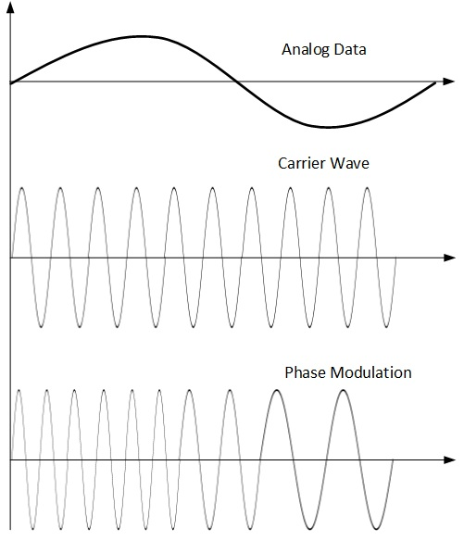

**PRECAUTIONS:**

1. Connect the circuit properly.

2. Apply the required voltages wherever needed.

3. Do not apply stress on the components.

**RESULT:**

Phase modulated waveform observed.

**EXPERIMENT NO -12**

**AIM:**

Study of Phase Demodulation.

**APPARATUS REQUIRED:**

1. Phase modulation and Demodulation kit
2. CRO
3. Set of patching tips
4. AFO
5. DMM

**THEORY:**

Demodulation is the act of extracting the original information-bearing signal from a modulated [carrier wave](http://en.wikipedia.org/wiki/Carrier_wave). A demodulator is an [electronic circuit](http://en.wikipedia.org/wiki/Electronic_circuit) (or [computer program](http://en.wikipedia.org/wiki/Computer_program) in a [software-defined radio](http://en.wikipedia.org/wiki/Software-defined_radio)) that is used to recover the information content from the modulated wave. There are many types of [modulation](http://en.wikipedia.org/wiki/Modulation) so there are many types of demodulators. The signal output from a demodulator may represent sound (an [analog](http://en.wikipedia.org/wiki/Analog_signal) [audio signal](http://en.wikipedia.org/wiki/Audio_signal)), images (an analog [video signal](http://en.wikipedia.org/wiki/Video_signal)) or [binary](http://en.wikipedia.org/w/index.php?title=Binary_signal&action=edit&redlink=1) data (a [digital signal](http://en.wikipedia.org/wiki/Digital_signal)).

In Phase demodulation original baseband signal recovered from the phase modulated signal.

**PROCEDURE:**

1. Switch on the trainer kit.
2. Check the power supply to be +12,+5,-5v.
3. Study the circuit as per the circuit diagram.
4. Connect the AF input at the corresponding terminal.
5. IC XR2206 is provided to generate 100Khz carrier wave frequency .
6. With the help of CRO observe the PM output at the output terminal.
7. By increasing the 100K potentiometer in clockwise direction you will observing the change in the phase modulation output, which in turn you can able to calculate the variable change in the “MODULATION INDEX”.
8. Connect the PM to the demodulated section input.
9. Vary the potentiometer to get the demodulated output waveform

**PRECAUTIONS:**

1. Connect the circuit properly.

2. Apply the required voltages wherever needed.

3. Do not apply stress on the components.

**RESULT:**

Original baseband signal recovered from Phase modulated wave.

**EXPERIMENT NO -13**

**AIM:-**

Analysis of voltage controlled oscillator using PLL chip (565).

**APPARATUS REQUIRED:-**

1. Experiment kit
2. Connecting probes
3. CRO.

**THEORY:-**

The LM 656 is a general purpose phase locked loop (PLL) containing a stable, highly linear voltage controlled Oscillator (VCO) for low distortion FM demodulator and doubled phase detector with good carrier suppressions. VCO frequency is set with internal resister &capacitor and tunning range of 10:1 can be obtained with the same capacitor.

The characteristics of the close loop system Bandwidth, response speed, capture & pull in range may be adjusted over a wider range with an external resister and capacitor.

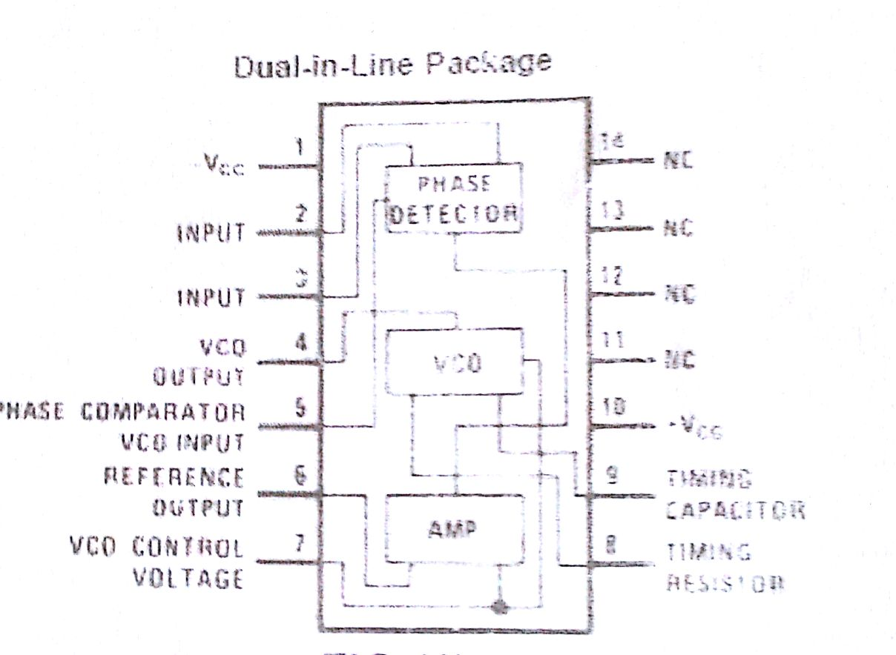

Fig (a) IC PLL 565

A basic VCO can be see in fig (b). It can show a basic voltage controlled oscillator by which frequency of oscillator is determined by L1,C2 & D2. D2 is so called varactor or varicap. Most common diodes will behave as a varicap, when reversed based but they must be operated below the junction breakdown parameters. With reverse bias, this diode will act as a capacitor, its depletion zone forming the dielectric properties changing the amount of reverse bias within the diodes breakdown level will alter the depletion zone width and hence vary the capacitance presented by the diode. This in turn changes the frequency response of the oscillator circuit.

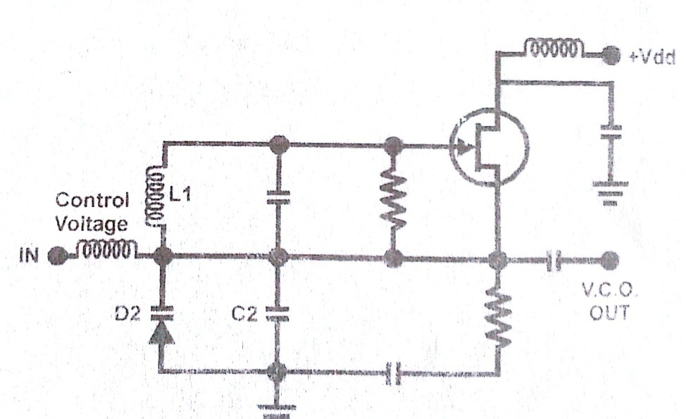

Fig(b) Basic VCO circuit

**PROCEDURE:-**

1. Switch ‘ON’ the instrument using ON/OFF switch and observe the waveform from voltage controlled oscillator on CRO.
2. Observe the effect of potentiometer i.e. (Offset frequency shifting) at VCO output on CRO.
3. Now set the offset frequency 5 KHz through potentiometer.
4. Now connect DC Variable output to the input signal through patch cords.
5. Observe the effect of DC voltage on VCO output i.e. the VCO output frequency is change according to the DC input.
6. Now remove the connection and give a 1KHz, 5V peak-to-peak sine wave DC offset at +5V from function generator to the input signal. A frequency modulated VCO output is observed on CRO.

**RESULT:-**

Analysis of voltage controlled oscillator using PLL chip (565) Completed.